**Data Structures Lab 04**

**Name:** Rameen Rafiq

**ID:** 22k-5167

**Section:** BSE-3B

**Question1**

public class q1 {

public void print(int[] array){

for(int i=0; i<array.length; i++){

System.*out*.print(array[i] + " ");

}

System.*out*.println(" ");

}

public static void main(String[] args) {

q1 obj = new q1();

int[] array;

array = new int[5];

array = new int[]{3, 1, 2, 5, 8};

System.*out*.println("Old array: ");

obj.print(array);

int[] newarray;

newarray = new int[8];

for(int j=0; j<array.length; j++){

newarray[j] = array[j];

}

System.*out*.println("Assigned old array to new array");

obj.print(newarray);

System.*out*.println("Adding elements");

newarray[5] = 9;

obj.print(newarray);

newarray[6] = 11;

obj.print(newarray);

newarray[7] = 4;

obj.print(newarray);

System.*out*.println("Deleting elements 1, 2 and 5");

newarray[1] = 0;

newarray[2] = 0;

newarray[3] = 0;

System.*out*.println("Printing array");

for(int i=0; i< newarray.length; i++){

if(newarray[i]!=0){

System.*out*.print(newarray[i] + " ");

}

}

}

}

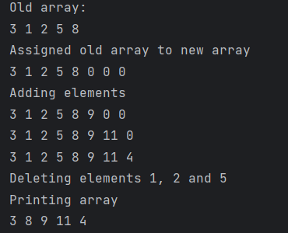

**Question 2**

**import java.util.Scanner;**

**class Node {**

**int data;**

**Node next;**

**public Node(int d){**

**data = d;**

**next = null;**

**}**

**}**

**public class q2 {**

**Node head;**

**public void insert(int d){**

**Node obj = new Node(d); //declare head here and rest elements from node class**

**if(head == null){**

**head = obj;**

**}**

**else{**

**Node current = head;**

**while(current.next != null){**

**current = current.next;**

**}**

**current.next = obj;**

**}**

**}**

**public void print(){**

**Node current = head;**

**while(current != null){**

**System.*out*.print(current.data + " ");**

**current = current.next;**

**}**

**System.*out*.println("null");**

**}**

**public void rotation(int n){**

**Node current = head;**

**while(current.next!= null){**

**current = current.next;**

**}**

**Node reference = head; //assigning new pointer at current reference**

**for(int i=0; i<n; i++){**

**current.next = reference;**

**current = current.next;**

**reference = reference.next;**

**}**

**current.next = null;**

**head = reference;**

**print();**

**}**

**public static void main(String[] args) {**

**q2 object = new q2();**

**object.insert(5);**

**object.insert(3);**

**object.insert(1);**

**object.insert(8);**

**object.insert(6);**

**object.insert(4);**

**object.insert(2);**

**object.print();**

**Scanner s = new Scanner(System.*in*);**

**System.*out*.println("Enter the number of rotations to perform: ");**

**int n = s.nextInt();**

**object.rotation(n);**

**}**

**}**

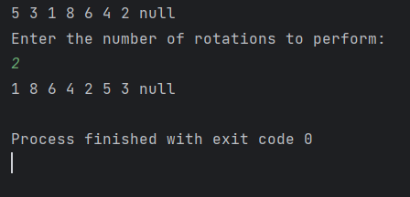

**Question 3**

**import java.util.Scanner;**

**class List{**

**int data;**

**List next;**

**List(int d){**

**data = d;**

**next = null;**

**}**

**public void delete(int element, List head){**

**List current;**

**List prev;**

**current = head;**

**int flag = 0;**

**while(current.next != null){**

**if(current.data == element){**

**flag = 1;**

**break;**

**}**

**prev = current;**

**current = current.next;**

**prev.next = current.next;**

**}**

**if(flag==0){**

**System.*out*.println("Element not found");**

**}**

**}**

**public void print(List obj){**

**List current = obj;**

**while(current != null){**

**System.*out*.println(current.data + " ");**

**current = current.next;**

**}**

**System.*out*.println("null");**

**}**

**}**

**public class q3 {**

**public static void main(String[] args) {**

**List obj1 = new List(3);**

**List obj2 = new List(4);**

**List obj3 = new List(5);**

**obj1.next = obj2;**

**obj2.next = obj3;**

**Scanner s = new Scanner(System.*in*);**

**System.*out*.println("Current elements in linked list: ");**

**obj1.print(obj1);**

**System.*out*.println("Enter the element to delete: ");**

**int element = s.nextInt();**

**obj1.delete(element, obj1);**

**System.*out*.println("Printing linked list after deletion: ");**

**obj1.print(obj1);**

**}**

**}**

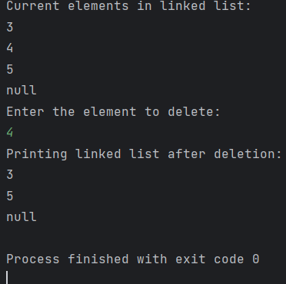

**Question 4:**

**import java.util.Scanner;**

**public class q4 {**

**int value;**

**q4 head;**

**q4 next;**

**public q4(int d){**

**value = d;**

**}**

**public void insert(int d){**

**q4 obj = new q4(d); //declare head here and rest elements from node class**

**if(head == null){**

**head = obj;**

**}**

**else{**

**q4 current = head;**

**while(current.next != null){**

**current = current.next;**

**}**

**current.next = obj;**

**}**

**}**

**public void print(){**

**q4 current = head;**

**while(current != null){**

**System.*out*.print(current.value + " ");**

**current = current.next;**

**}**

**System.*out*.println("null");**

**}**

**public void printvalues() {**

**q4 current = head;**

**System.*out*.println("Printing even values first then odd: ");**

**while(current != null) {**

**if ((current.value%2) == 0) {**

**System.*out*.print(current.value + " ");**

**}**

**current = current.next;**

**}**

**current = head;**

**while (current != null) {**

**if ((current.value % 2) != 0) {**

**System.*out*.print(current.value + " ");**

**}**

**current = current.next;**

**}**

**System.*out*.println(" ");**

**}**

**public static void main(String[] args) {**

**Scanner s = new Scanner(System.*in*);**

**System.*out*.println("Enter any 8 values (4 even, 4 odd)");**

**int input = s.nextInt();**

**q4 object = new q4(input);**

**for(int i=0;i<6;i++){**

**input = s.nextInt();**

**object.insert(input);**

**}**

**System.*out*.println("Printing complete linked list: ");**

**object.print();**

**System.*out*.println("Printing even values first then odd: ");**

**object.printvalues();**

**}**

**}**

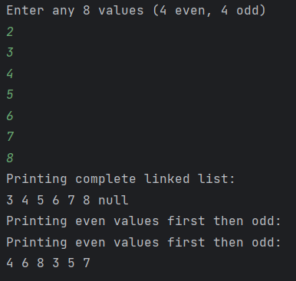

**Question 5:**

**import java.util.Scanner;**

**public class q5 {**

**int data;**

**q5 next;**

**q5 head;**

**public q5(){ //default constructor**

**}**

**public q5(int d){ //to assign object values of linked list**

**data = d;**

**}**

**public void addelement(int d){**

**q5 obj = new q5(d);**

**if(head == null){**

**head = obj;**

**}**

**else{**

**q5 current = head;**

**while(current.next != null){**

**current = current.next;**

**}**

**current.next = obj;**

**}**

**}**

**public void palindromecheck(){**

**q5 current = head;**

**int firstelement = current.data;**

**current = current.next; //at position 1**

**current = current.next; //at position 2**

**int secondelement = current.data;**

**current = current.next; //going to position 3**

**current = current.next; //now at position 4**

**if(current.data==secondelement){**

**current = current.next; //at position 5**

**if(current.data==firstelement){**

**System.*out*.println("Linked List is a palindrome");**

**}**

**else{**

**System.*out*.println("Linked List is not Palindrome");**

**}**

**}**

**else{**

**System.*out*.println("Linked List is not Palindrome");**

**}**

**}**

**public static void main(String[] args) {**

**Scanner s = new Scanner(System.*in*);**

**q5 obj = new q5();**

**System.*out*.println("Enter any 5 elements: ");**

**for(int i=0;i<5;i++){**

**int input = s.nextInt();**

**obj.addelement(input);**

**}**

**System.*out*.println("Checking if list is palindromic: ");**

**obj.palindromecheck();**

**}**

**}**

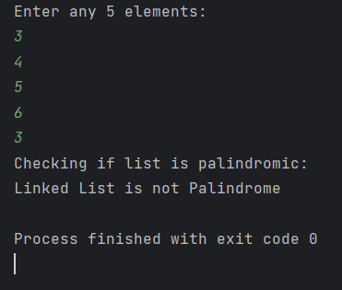

**Question 6:**

**public class q6 {**

**int data;**

**q6 next;**

**q6 head;**

**public q6(){ //default constructor**

**}**

**public q6(int d){ //constructor to initialize data of objects**

**data = d;**

**next = null;**

**}**

**public void insertend(int d){**

**q6 obj = new q6(d);**

**if(head == null){**

**head = obj;**

**obj.next = head; //points to itself if first element**

**}**

**else{**

**q6 current = head;**

**while(current.next != head){**

**current = current.next;**

**}**

**current.next = obj;**

**obj.next = head; //new inserted element points to head for circular linked list**

**}**

**}**

**public void insertstart(int d){**

**q6 obj = new q6(d);**

**if(head == null){**

**head = obj;**

**obj.next = head; //points to itself if first element**

**}**

**else{**

**q6 current = head;**

**while(current.next != head){**

**current = current.next;**

**}**

**current.next = obj;**

**obj.next = head; //new inserted element points to head for circular linked list**

**head = obj; //the new element is now head**

**}**

**}**

**public void insertmiddle(int d, int position){**

**if(position==0){ //if first position, object will be created in insertstart function**

**insertstart(d);**

**}**

**q6 obj = new q6(d);**

**q6 current = head;**

**int currentposition = 0; //start from head and traverse till given index**

**while(current!=null && currentposition<(position-1)){**

**current = current.next;**

**currentposition++;**

**}**

**if(current==null){**

**System.*out*.println("Linked List is not long enough");**

**return;**

**}**

**obj.next = current.next; //new object point to next of current object**

**current.next = obj; //current object points to new object**

**}**

**public void delete(int element){**

**q6 current;**

**q6 previous = null;**

**current = head; //start from first element**

**while(current.next!=null){**

**if(current.data==element){**

**break; //element found in list so break loop**

**}**

**previous = current;**

**current = current.next;**

**}**

**previous.next = current.next; //element to delete address' removed**

**}**

**public void print(){**

**q6 current = head;**

**int check = head.data;**

**System.*out*.print(current.data + " "); //print first element's data**

**current = current.next;**

**while(current.data!=check){**

**System.*out*.print(current.data + " ");**

**current = current.next;**

**}**

**}**

**public static void main(String[] args) {**

**q6 obj = new q6();**

**System.*out*.println("Adding elements in Linked List: ");**

**obj.insertend(3);**

**obj.insertend(4);**

**obj.insertend(12);**

**obj.insertend(13);**

**obj.print();**

**System.*out*.println("\nInserting element in start of Linked List");**

**obj.insertstart(2);**

**obj.print();**

**System.*out*.println("\nInserting element at middle position: ");**

**obj.insertmiddle(10, 4);**

**obj.print();**

**System.*out*.println("\nDeleting an element: ");**

**obj.delete(3);**

**obj.print();**

**}**

**}**

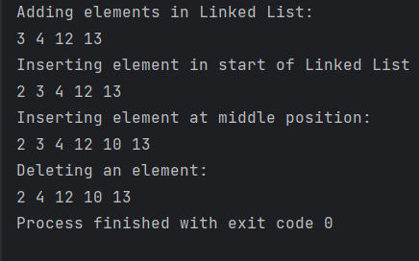

**Question 7:**

**public class q7 {**

**int data;**

**q7 next;**

**q7 head;**

**public q7(int d){**

**data = d;**

**next = null;**

**}**

**public void print(q7 obj){**

**q7 current = obj;**

**while(current != null){**

**System.*out*.print(current.data + " ");**

**current = current.next;**

**}**

**System.*out*.println("null");**

**}**

**public void concatenate(q7 L, q7 M){**

**q7 Lhead = L;**

**while(Lhead.next !=null){ //traversing till end of List L**

**Lhead = Lhead.next;**

**}**

**Lhead.next = M;**

**System.*out*.println("Lists L and M have been concatenated");**

**}**

**public static void main(String[] args) {**

**//Creating objects for List L**

**q7 L1 = new q7(3);**

**q7 L2 = new q7(4);**

**q7 L3 = new q7(5);**

**L1.next = L2;**

**L2.next = L3;**

**//Creating objects for List M**

**q7 M1 = new q7(10);**

**q7 M2 = new q7(12);**

**q7 M3 = new q7(13);**

**M1.next = M2;**

**M2.next = M3;**

**M1.head = M1;**

**System.*out*.println("Printing List L");**

**L1.print(L1);**

**System.*out*.println("Printing List M");**

**M1.print(M1);**

**L1.concatenate(L1, M1);**

**System.*out*.println("Printing concatenated list");**

**L1.print(L1);**

**}**

**}**

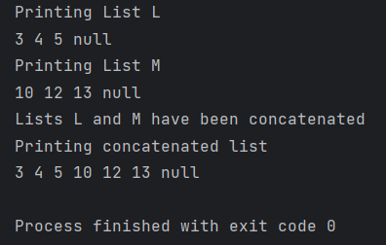

**Question 8:**